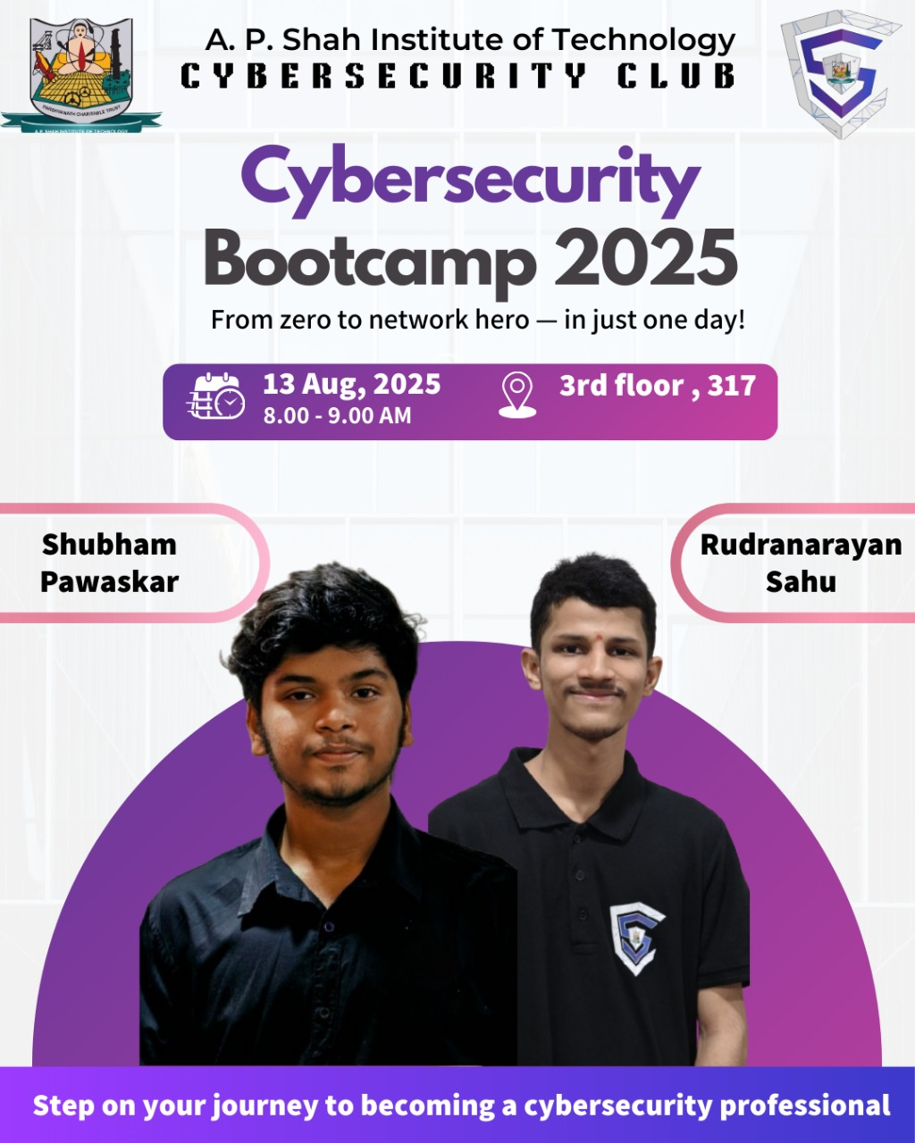
Session: Bootcamp 2025 Session 2 (Networking Fundamentals)

Name of College: A. P. Shah Institute of Technology, Kasarvadavali, Ghodbunder Road, Thane – 400615

Date: 13/08/2025
Venue: 317
Participants:
Targeted Audience: Students Interested in Cybersecurity learning domain from IT, CS, DS, AIML Department.
Speaker:
- Shubham Pawaskar (Technical Co-head)
- Rudranarayan Sahu (Technical Co-head)

Faculty Accompanied:

Prof. Sneha Dalvi

Prof. Randeep Kaur Kahlon

Prof. Saylee Lapalikar

Prof. Manjusha Kashilkar.

Organizers:
Cybersecurity Club, A. P. Shah Institute of Technology

Aim of Event: The session aimed to provide students with both theoretical knowledge and practical exposure to networking concepts. It emphasized the significance of networking as the foundation of cybersecurity, while also equipping participants with terminal-based skills essential for real-world applications.
The Cyber Security Club organized a hands-on session on Networking Fundamentals to provide students with both theoretical insights and practical exposure. The session began with an introduction to networking as the foundation of digital communication, emphasizing its role in enabling resource sharing, instant file transfers, and seamless communication. Real-life analogies, such as a firewall acting as a security guard, network monitoring as CCTV surveillance, and encryption as a secure courier service, helped students connect networking concepts to cybersecurity applications.
The session stood out for its practical approach, where participants explored terminal-based commands to identify their IP and MAC addresses, analyze network configurations, and understand how devices communicate within a network. Students also gained exposure to essential tools such as ping, traceroute, netstat, and nslookup, along with explanations of DNS, subnetting, CIDR, networking devices like routers and switches, and concept of Subnetting. These demonstrations bridged theory with practice, enabling participants to visualize real-world troubleshooting and security monitoring techniques.
Overall, the session was highly beneficial and well-received by the students. It enhanced their confidence in using networking tools, strengthened their conceptual understanding, and highlighted the importance of networking as the bedrock of cybersecurity. The event concluded with a strong message that mastering networking fundamentals is a vital step toward becoming proficient cybersecurity professionals.

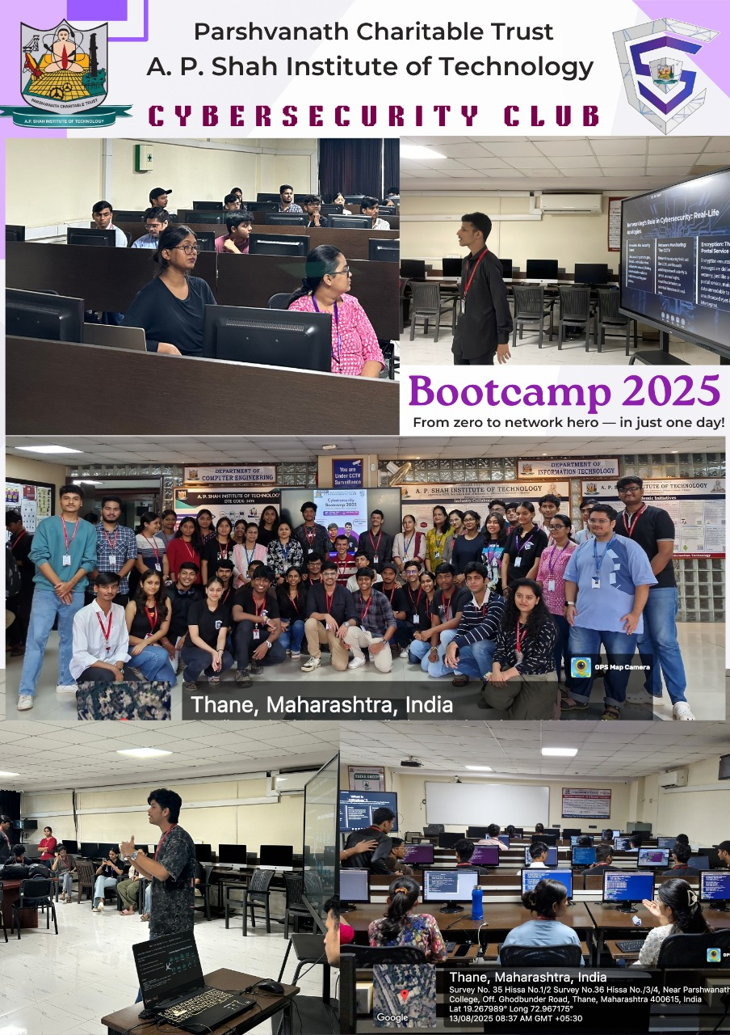

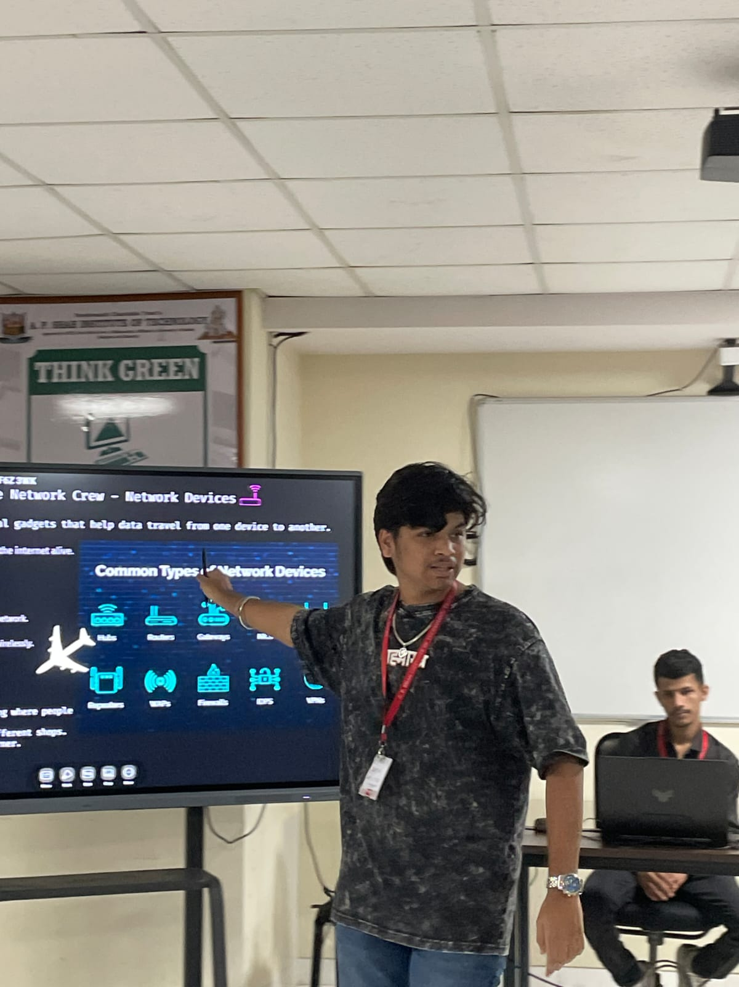
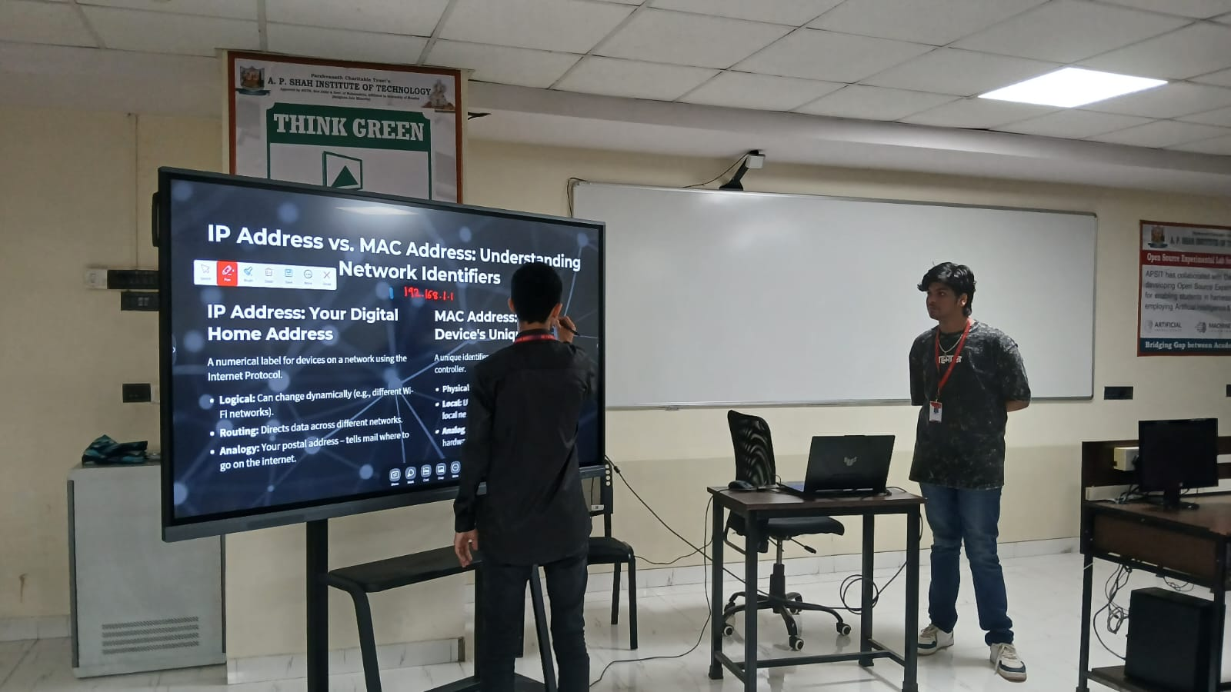

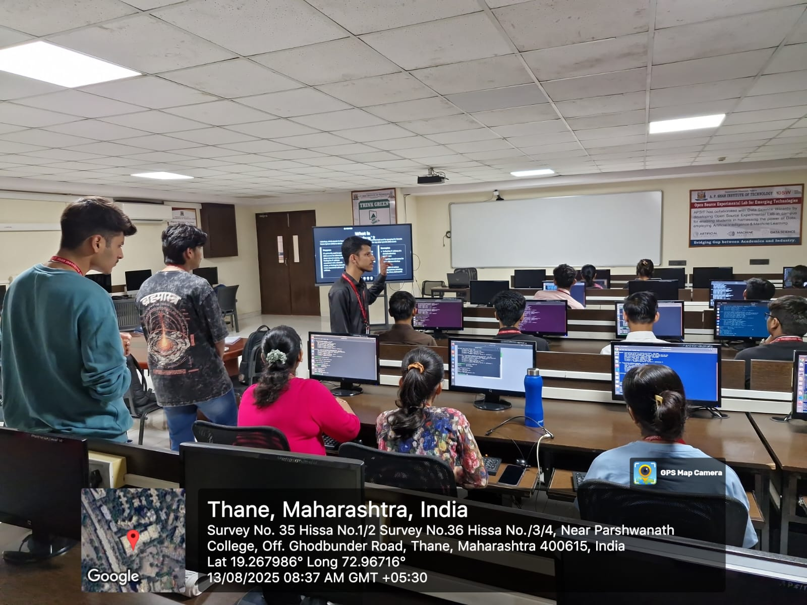
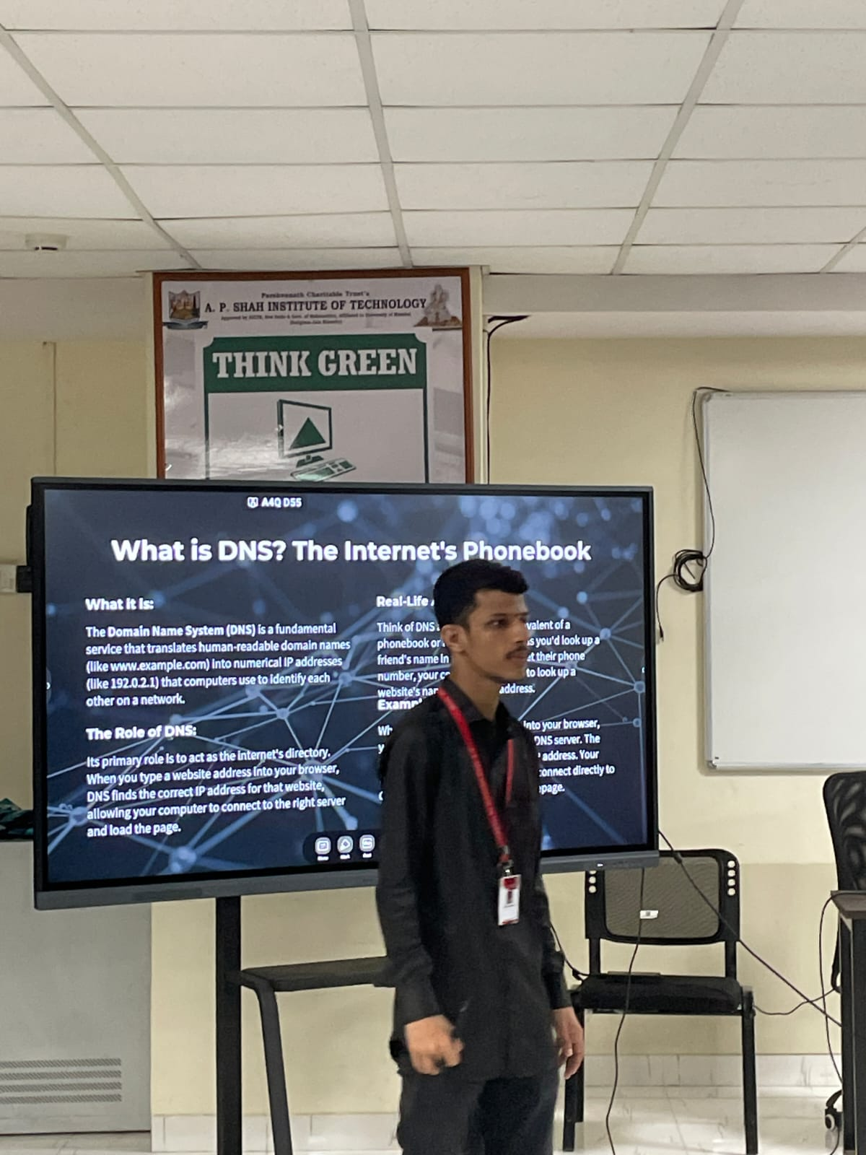
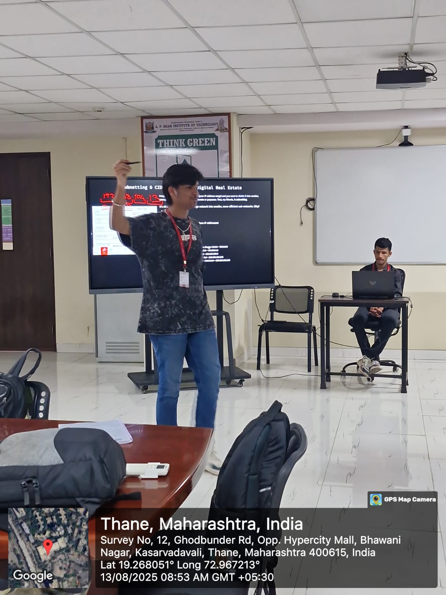
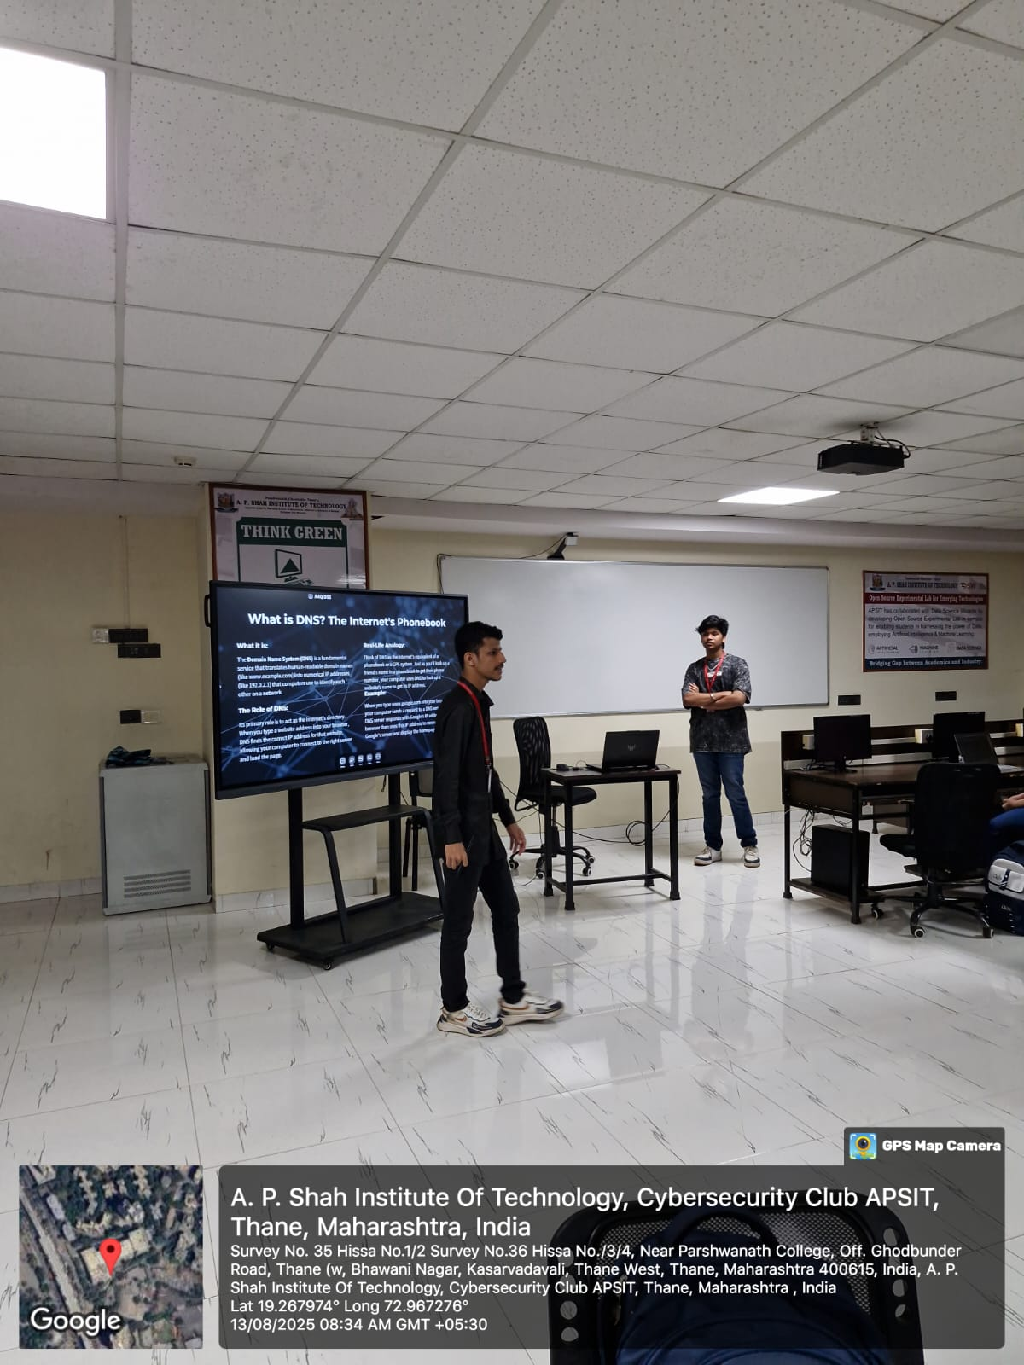
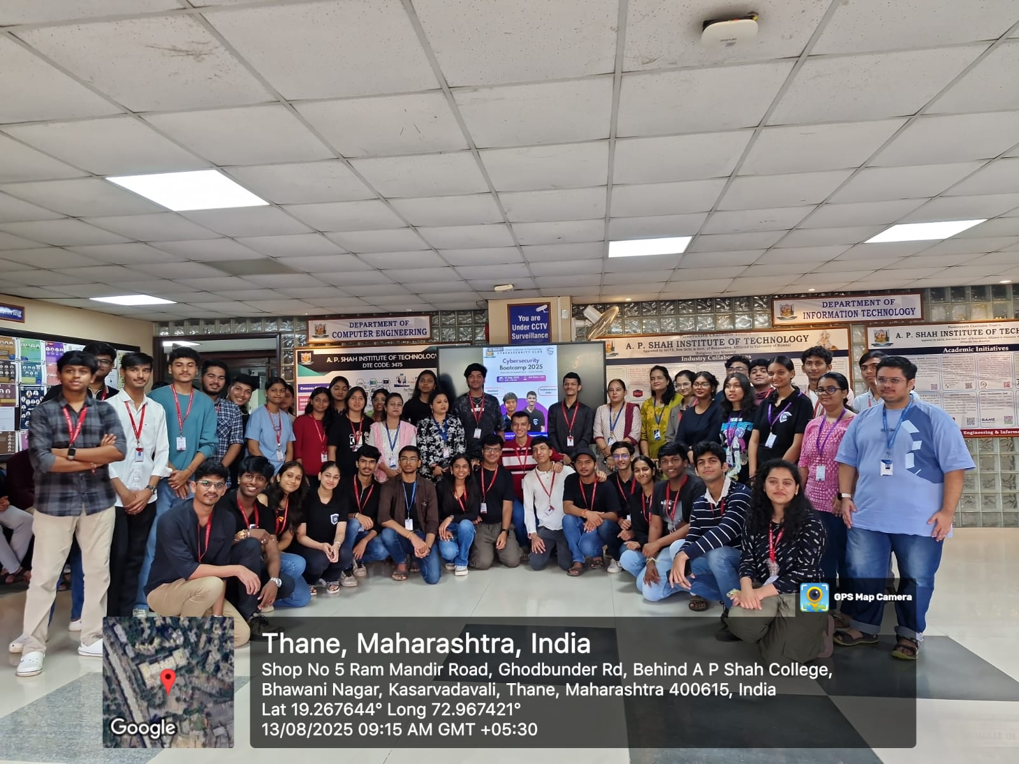

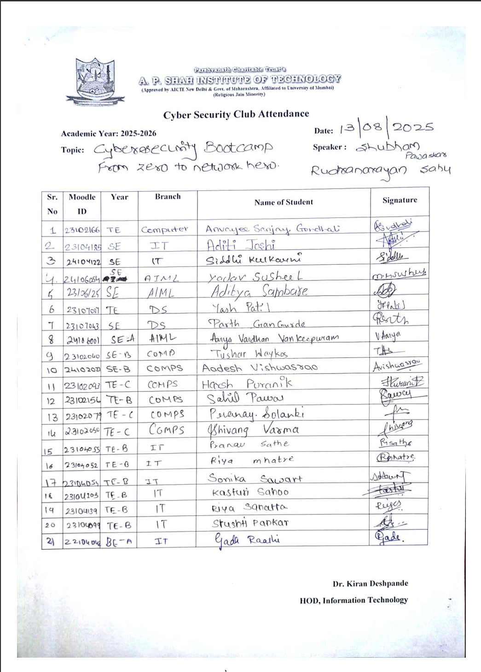

Feedback form Analysis:


